1
Since u=sin((k+0.5)πx);
u’=(k+0.5)π*cos((k+0.5)πx);
So u(0)=sin(0)=0
U’(1)=(k+0.5)π*cos((k+0.5)π)=(k+0.5)π*0=0
u’’=-(k+0.5)²*π²*sin((k+0.5)πx);
So f=-u’’=(k+0.5)²*π²*sin((k+0.5)πx);
2_a:
Notations: -u’’(x) = f(x)
u=sin[(k+0.5)π * x]
f=(k+0.5)² * π² * u
h=1/n
Ritz-Galerkin Approximation of error: (Upper bound)
E0=0.5*h²*||f||;

Errors:
k  n | 1  ||f||=15.7 | 2  ||f||=43.6 | 4  ||f||=141.3 | 8  ||f||=504.2 | 16  ||f||=1900.0 | 32  ||f||=7371.4
5 | Error:  5.62*10⁻²  Upper Bound:  0.314 | Error:  0.151  Upper Bound:  0.872 | Error:  0.432  Upper Bound:  2.82 | Error:  0.950  Upper Bound:  10.1 | Error:  0.840  Upper Bound:  38.0 | Error:  0.910  Upper Bound:  147
10 | Error:  1.43*10⁻²  Upper Bound:  7.85*10⁻² | Error:  3.93*10⁻²  Upper Bound:  0.218 | Error:  0.123  Upper Bound:  0.707 | Error:  0.393  Upper Bound:  2.52 | Error:  0.932  Upper Bound:  9.50 | Error:  0.826  Upper Bound:  36.9
20 | Error:  3.58*10⁻³  Upper Bound:  1.96*10⁻² | Error:  9.92*10⁻³  Upper Bound:  5.45*10⁻² | Error:  3.19*10⁻²  Upper Bound:  0.177 | Error:  0.111  Upper Bound:  0.630 | Error:  0.373  Upper Bound:  2.37 | Error:  0.922  Upper Bound:  9.21
40 | Error:  8.95*10⁻⁴  Upper Bound:  4.91*10⁻³ | Error:  2.49*10⁻³  Upper Bound:  1.36*10⁻² | Error:  8.04*10⁻³  Upper Bound:  4.42*10⁻² | Error:  2.85*10⁻²  Upper Bound:  0.158 | Error:  0.104  Upper Bound:  0.594 | Error:  0.364  Upper Bound:  2.31
80 | Error:  2.24*10⁻⁴  Upper Bound:  1.23*10⁻³ | Error:  6.22*10⁻⁴  Upper Bound:  3.41*10⁻³ | Error:  2.01*10⁻³  Upper Bound:  1.10*10⁻² | Error:  7.17*10⁻³  Upper Bound:  3.93*10⁻² | Error:  2.69*10⁻²  Upper Bound:  0.148 | Error:  0.101  Upper Bound:  0.576
The error is going down by approximately 1/4 (as expected), when we half h and h²*||f|| is small enough. The error behaves like h². (If we fit error and h², we can see they can fit into straight line quite well.)
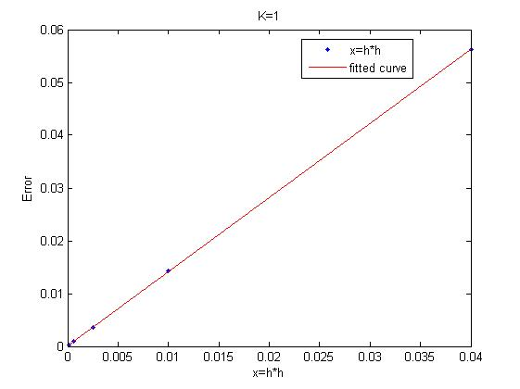
The error is also growing with the growth of ||f||. But I can’t show the linearity. That probably is due to the function is quite smooth and the error is too far away from the estimate.
Pictures: (We only show k=1, k=2, k=4 here. Please refer to the code for the rest.)
k  n | 1 | 2 | 4
5 | 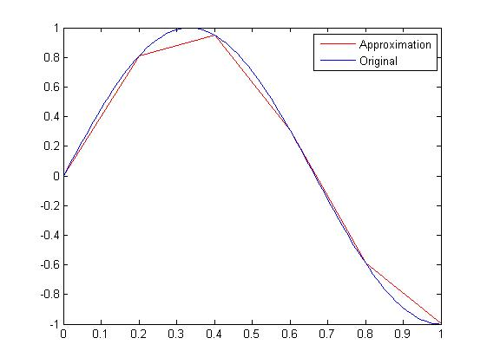 | 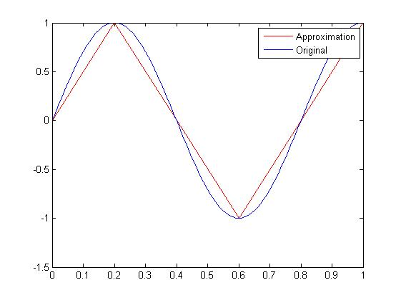 | 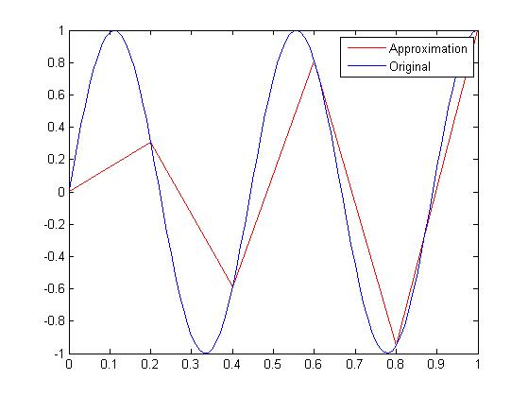
10 | 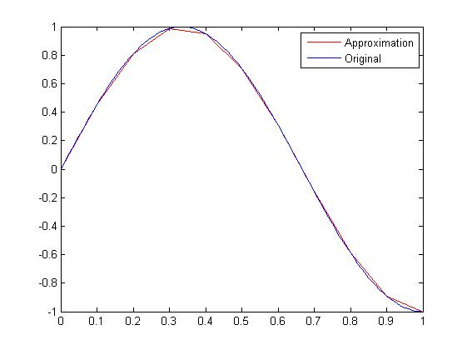 | 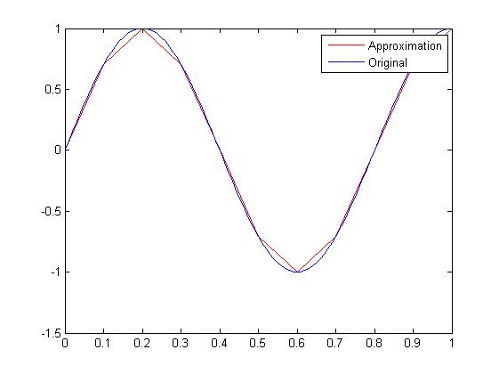 | 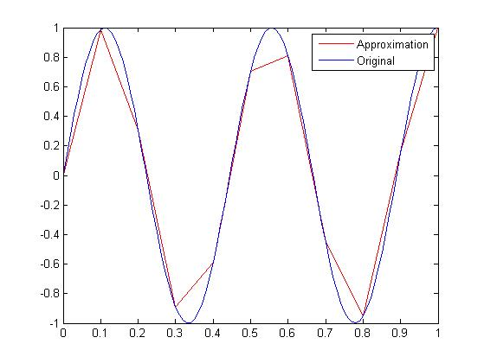
20 | 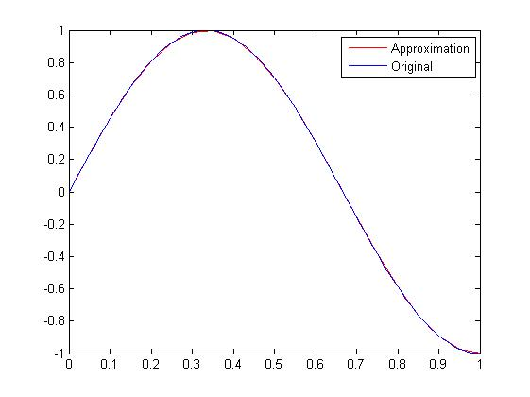 | 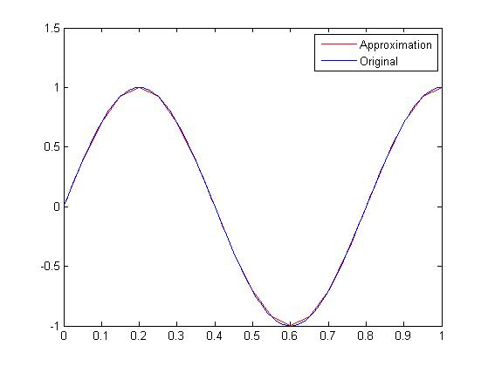 | 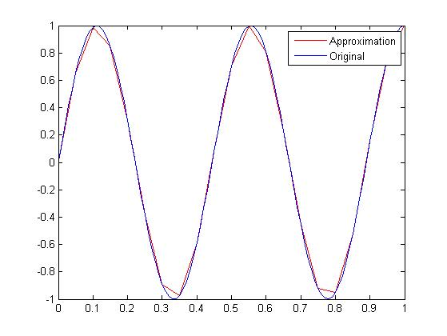
40 | 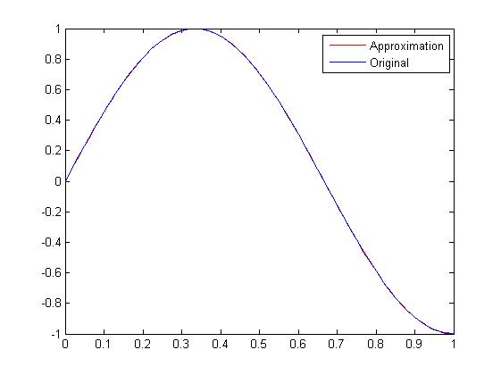 | 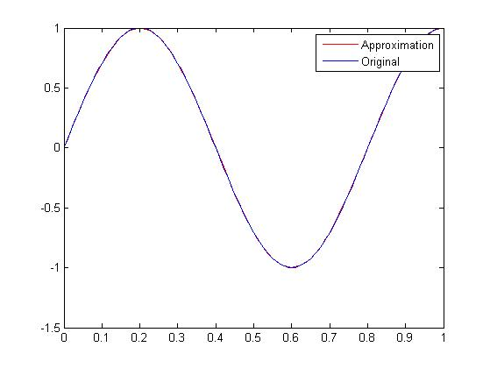 | 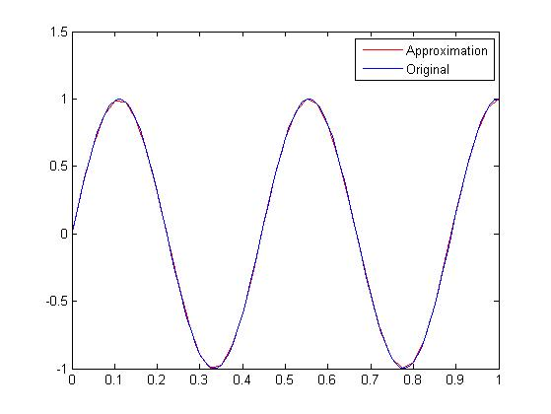
80 | 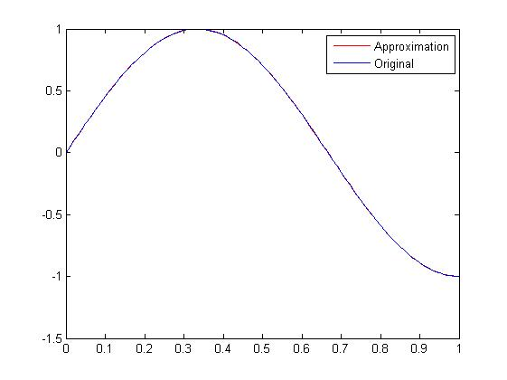 | 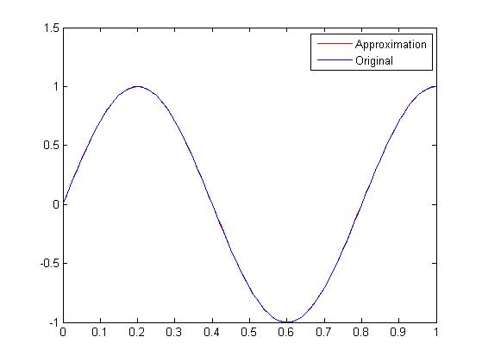 | 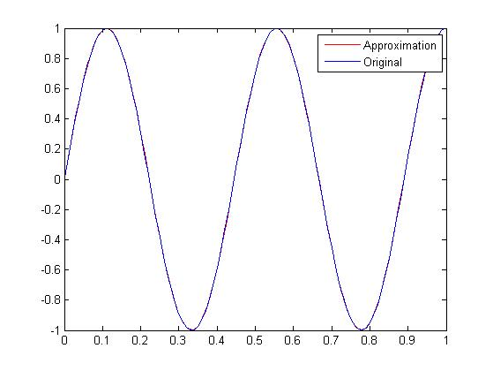
2_b:
Notations: -u’’(x) = f(x)
h=1/n
Ratio: error/upper_bound
Func  tion  n | F = sin(π*x)  u = π²*sin(π*x)  F is C∞; ||F||=6.98; | F= | 24x (x<0.5)  24(1-x) (x≥0.5) | F is C⁰  ||F||=6.93 | F= | 4.4 (x≤0.5)  8.8 (x>0.5) | F is discont  ||F||=6.96
Func  tion  n | F = sin(π*x)  u = π²*sin(π*x)  F is C∞; ||F||=6.98; | u= | -(4x³-3x) (x<0.5)  -[4(1-x)³+3x-3] (x≥0.5) |  | u= | -2.2x²+2.75x (x≤0.5)  -4.4x²+4.95x-0.45 (x>0.5)
5 | Error:  2.53*10⁻²  Upper Bound:  0.140  Ratio:  0.181 | Error:  2.53*10⁻²  Upper Bound:  0.139  Ratio:  0.181 |  |  | Error:  2.52*10⁻²  Upper Bound:  0.139  Ratio:  0.181
10 | Error:  6.35*10⁻³  Upper Bound:  3.50*10⁻²  Ratio:  0.182 | Error:  6.29*10⁻³  Upper Bound:  3.46*10⁻²  Ratio:  0.182 |  |  | Error:  6.35*10⁻³  Upper Bound:  3.48*10⁻²  Ratio:  0.182
20 | Error:  1.59*10⁻³  Upper Bound:  8.72*10⁻³  Ratio:  0.182 | Error:  1.58*10⁻³  Upper Bound:  8.66*10⁻³  Ratio:  0.182 |  |  | Error:  1.59*10⁻³  Upper Bound:  8.70*10⁻³  Ratio:  0.182
40 | Error:  3.98*10⁻⁴  Upper Bound:  2.18*10⁻³  Ratio:  0.182 | Error:  3.95*10⁻⁴  Upper Bound:  2.17*10⁻³  Ratio:  0.182 |  |  | Error:  3.95*10⁻⁴  Upper Bound:  2.17*10⁻³  Ratio:  0.182
80 | Error:  9.96*10⁻⁵  Upper Bound:  5.45*10⁻⁴  Ratio:  0.183 | Error:  9.88*10⁻⁵  Upper Bound:  5.41*10⁻⁴  Ratio:  0.183 |  |  | Error:  1..01*10⁻⁴  Upper Bound:  5.44*10⁻⁴  Ratio:  0.187
Here we look into F is C∞, C⁰, discontinuous respectively. Therefore, u is C∞, C², C¹ respectively. It seems that the smoothness doesn’t affect much on the error.
Pictures:
Func  tion  n | F = sin(π*x)  u = π²*sin(π*x)  F is C∞; ||F||=6.98;  u is C∞ | F= | 24x (x<0.5)  24(1-x) (x≥0.5) | F is C¹  ||F||=6.93 | F= | 4.4 (x≤0.5)  8.8 (x>0.5) | F is discont  ||F||=6.96
Func  tion  n | F = sin(π*x)  u = π²*sin(π*x)  F is C∞; ||F||=6.98;  u is C∞ | u= | 4x³-3x (x<0.5)  4(1-x)³+3x-3 (x≥0.5) |  | u= | -2.2x²+2.75x (x≤0.5)  -4.4x²+4.95x-0.45 (x>0.5)
5 | 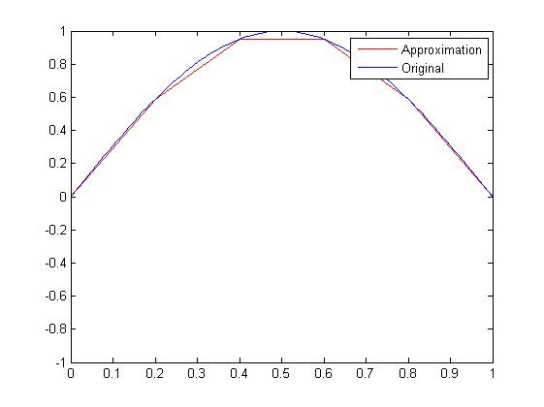 | 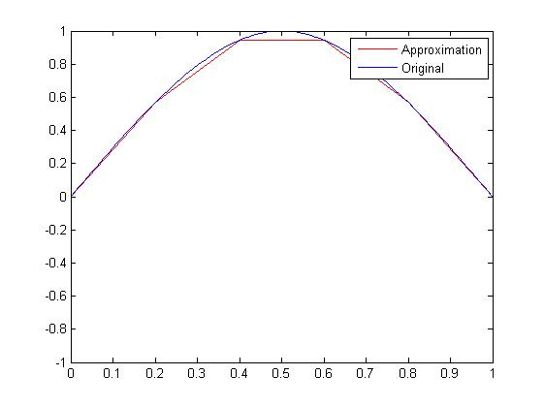 |  |  | 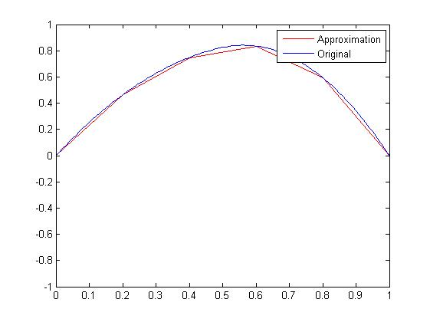
10 | 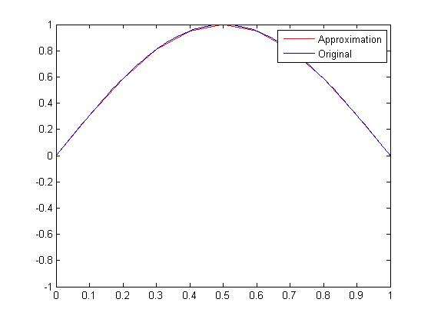 | 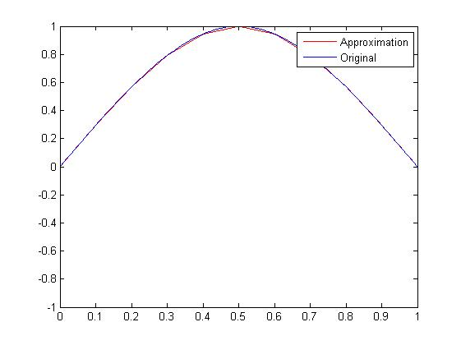 |  |  | 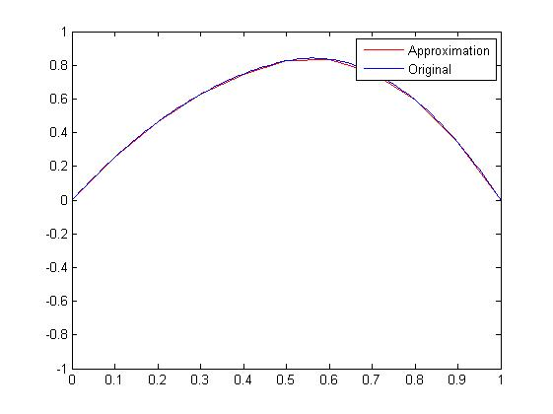
20 | 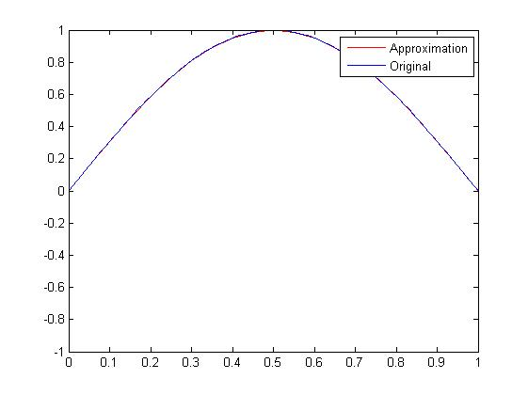 | 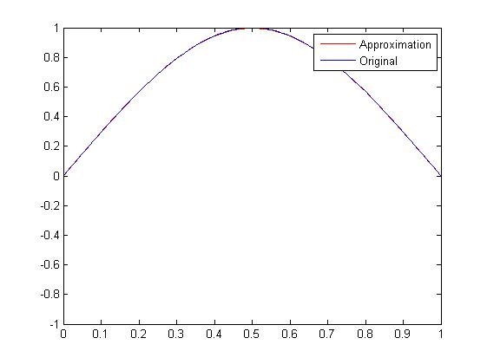 |  |  | 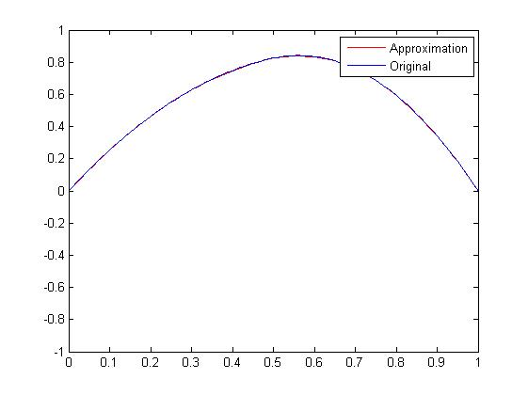
40 | 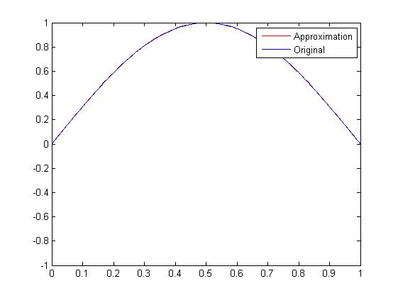 | 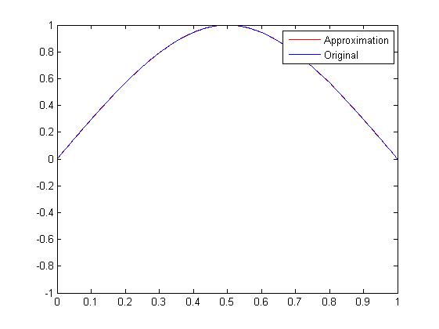 |  |  | 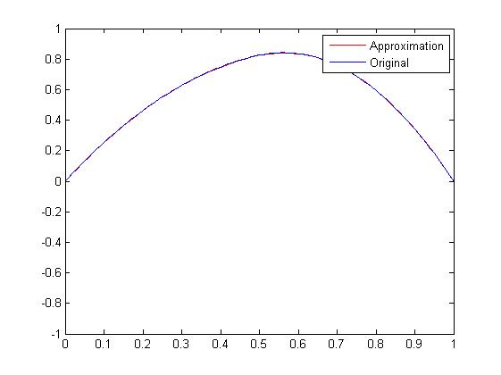
80 | 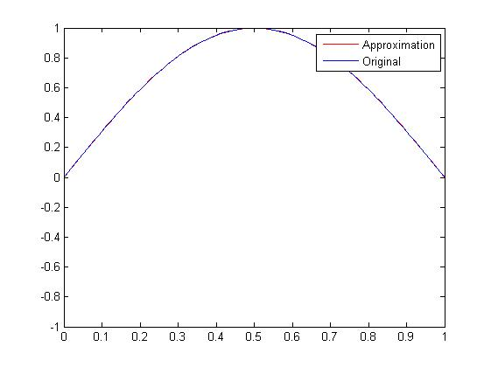 | 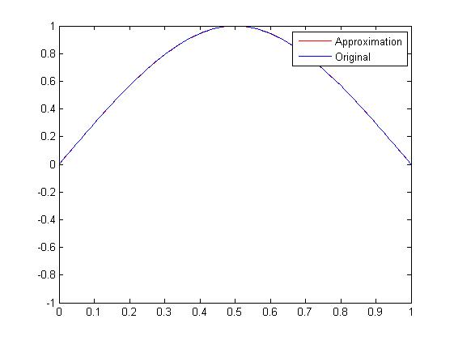 |  |  | 